Makerere  university
college of computing and information sciences
Department of networks

Course: Bachelor of science in software engineering
Course UNIT: ARTIFICIAL INTELLIGENCE
course Code: CSC 2114
coursework title: IMPLEMENTING UNINFORMED SEARCH USING BFS AND DFS USING A CAMPUS USE CASE

GROUP: B2
GROUP MEMBERS
NAME | REGISTRATION NUMBER
SSEKIJJOBA FRANCIS | 25/U/04324/PS
NASSUUNA PATIENCE R | 25/U/04295/PS
NUWAGABA DUNCAN | 25/U/0392
OYET ANTHONY ELIZEOUS | 25/E/04316/PS
BIDAL DANIEL | 25/E/04188/PS

1. Problem formulation
- Initial state (an element of the set of states). The source school chosen by the user, for example School of Law.
- Action(s) (a function from a state to a set of actions). Given a place, it returns one action Go(n) for each place n directly connected to it. In the code this is read off the adjacency list GRAPH[s]. Because connections are two-way, if n is a neighbour of s then s is a neighbour of n. Example: Actions(School of Law) = {Go(Freedom Square), Go(School of Economics)}. Landmarks have actions too, because they can be walked through. Neighbours are taken in alphabetical order so the search is deterministic.
- Transition model Result(s, a) (a function from a state and an action to a state). Result(s, Go(n)) = n. Walking to n always ends at n. Example: Result(Main Library, Go(School of Education)) = School of Education.
- Goal test (a Boolean test on a state). It returns True if the current place is the destination school chosen by the user, and False otherwise. It looks only at the place, not at how the visitor got there.
- Path cost (a number, the sum of step costs). Every step costs 1, so the cost of a route is its number of hops. The step cost is 1 because the assignment ignores walking distance, so the best route is the one with the fewest hops.
.

Abstraction
The state records only which place the visitor is at. It deliberately ignores:
- distance and slope (two connected places may be 50 m or 500 m apart on a hilly campus, yet every edge costs
- weather and time of day (rain, heat, darkness and crowds change the quality of a walk, not which places connect
- traffic and access (vehicles, security barriers, locked buildings and walking speed).
Dropping these is valid because none of them changes which place can be reached from which, so any route found in the abstraction is still a valid sequence of connected places. It is useful because the state space shrinks to 18 states, small enough to search exhaustively and check by hand. The current place is a sufficient summary of the past for choosing the next action.

State versus node
A state is a place on campus. A node is a position in the search tree holding a state, its parent, the action and the path cost, so one state can appear in many nodes. In tree-like search from School of Law, the state Main Library appears in two nodes: School of Law → Freedom Square → Main Library and School of Law → School of Economics → Main Library (both PATH-COST 2). Even the root state can reappear, as in School of Law → Freedom Square → School of Law. This is why graph search needs the reached table: with it on, the second Main Library node is never created.

2. Design
Node. A class with the four lecture fields: STATE (the place), PARENT (the node that generated it), ACTION (the place walked to) and PATH-COST (the parent’s cost plus 1).
Solution(node) follows PARENT pointers to the root and reverses the list to give the route.
Frontier. A deque. BFS is a queue and removes from the front (pop left);
DFS is a stack and removes from the back (pop). This removal line is the only difference between the two algorithms. For DFS the sorted neighbours are pushed in reverse so the alphabetically first neighbour is on top of the stack.
Reached. A dictionary mapping a state to the node that first generated it. A child is added to the frontier only if its state is not in reached. A switch (--no-reached) turns it off to give tree-like search, which is stopped by the 10,000-expansion cap.
SEARCH(source, destination, strategy, use_reached):
root ← Node(source, parent=None, action=None, cost=0)
frontier ← [root]; reached ← {source: root}; expanded ← 0
while frontier is not empty:
node ← front of frontier if BFS (queue) else back of frontier (stack)
if node.state = destination: return SOLUTION(node), expanded # goal test on removal
if expanded ≥ 10,000: return failure (cap)
expanded ← expanded + 1
neighbours ← sorted(GRAPH[node.state]); if DFS: reverse(neighbours)
for place in neighbours:
if use_reached and place in reached: continue
child ← Node(place, node, place, node.cost + 1)
if use_reached: reached[place] ← child
add child to back of frontier
return failure # "No route found."

3. Results
Ten school-to-school pairs (landmarks are walk-through only), each run with BFS and DFS (reached table on, neighbours alphabetical). Key: MB Main Building; FS Freedom Square; ML Main Library; CTF Central Teaching Facility; LPA School of Liberal and Performing Arts; MTS Margaret Trowell School; BE School of the Built Environment; ENG School of Engineering; SPS School of Statistics and Planning; LAW School of Law; ECON School of Economics; SSC School of Social Sciences; EDU School of Education; CNS College of Natural Sciences; FTN School of Food Technology, Nutrition and Bioengineering; AGR School of Agricultural Sciences; VET School of Veterinary Medicine.
# | Source | Destination | Algorithm | Route | Cost (hops) | Nodes expanded
1 | LAW | MTS | BFS | LAW → FS → MB → LPA → MTS | 4 | 12
1 | LAW | MTS | DFS | LAW → FS → CTF → CoCIS → ENG → MTS | 5 | 5
2 | CoCIS | ENG | BFS | CoCIS → ENG | 1 | 2
2 | CoCIS | ENG | DFS | CoCIS → ENG | 1 | 16
3 | VET | CoCIS | BFS | VET → AGR → FTN → CNS → EDU → ML → FS → CTF → CoCIS | 8 | 14
3 | VET | CoCIS | DFS | VET → AGR → FTN → CNS → EDU → ML → FS → CTF → CoCIS | 8 | 8
4 | ECON | CoCIS | BFS | ECON → SPS → CoCIS | 2 | 8
4 | ECON | CoCIS | DFS | ECON → ML → FS → CTF → CoCIS | 4 | 4
5 | EDU | LAW | BFS | EDU → ML → FS → LAW | 3 | 10
5 | EDU | LAW | DFS | EDU → ML → FS → LAW | 3 | 14
6 | ECON | BE | BFS | ECON → SPS → CoCIS → ENG → BE | 4 | 15
6 | ECON | BE | DFS | ECON → ML → FS → CTF → CoCIS → ENG → BE | 6 | 8
7 | CNS | AGR | BFS | CNS → FTN → AGR | 2 | 5
7 | CNS | AGR | DFS | CNS → FTN → AGR | 2 | 16
8 | SSC | SPS | BFS | SSC → MB → FS → CTF → SPS | 4 | 13
8 | SSC | SPS | DFS | SSC → MB → FS → CTF → SPS | 4 | 8
9 | EDU | AGR | BFS | EDU → CNS → FTN → AGR | 3 | 8
9 | EDU | AGR | DFS | EDU → CNS → FTN → AGR | 3 | 3
10 | LPA | CoCIS | BFS | LPA → MTS → ENG → CoCIS | 3 | 12
10 | LPA | CoCIS | DFS | LPA → MB → FS → CTF → CoCIS | 4 | 4
Conditions met: BFS and DFS differ on pairs 1, 4, 6 and 10; pair 2 (CoCIS and ENG) is a directly connected pair of schools; pair 3 (VET to CoCIS) is 8 hops apart.
B4: reached table on and off. DFS from School of Law to Margaret Trowell School finds the 5-hop route after 5 expansions with reached on. With reached off it hits the 10,000-expansion cap, prints a warning and then "No route found.". The cause is the cycles. Every two-way edge is itself a cycle of length 2, and the neighbour order makes DFS fall into one: CTF’s alphabetically first neighbour is CoCIS, and CoCIS’s alphabetically first neighbour is CTF, so DFS bounces CTF → CoCIS → CTF → … forever and never pops the School of Engineering branch that leads to the goal. With reached on, CTF and CoCIS are recorded when first generated and never pushed again, so DFS moves on to its next neighbour.

4. Analysis

Why BFS returns a fewest-hops route
BFS removes nodes in FIFO order, so nodes leave the frontier in non-decreasing depth. Every step costs 1, so depth equals PATH-COST following the condition that all step costs are equal ie .1 on a finite graph. Then the first time the goal is removed, no shallower route can exist, since every shallower node was removed first. The reached table does not break this, because BFS first reaches a state by its shallowest path. In our results BFS cost ≤ DFS cost on all ten pairs (for example 8 hops for VET to CoCIS, which is the true distance).

A pair where DFS returns a longer route
School of Law to Margaret Trowell School (pair 1): BFS finds LAW → FS → MB → LPA → MTS (4 hops) and DFS finds LAW → FS → CTF → CoCIS → ENG → MTS (5 hops).
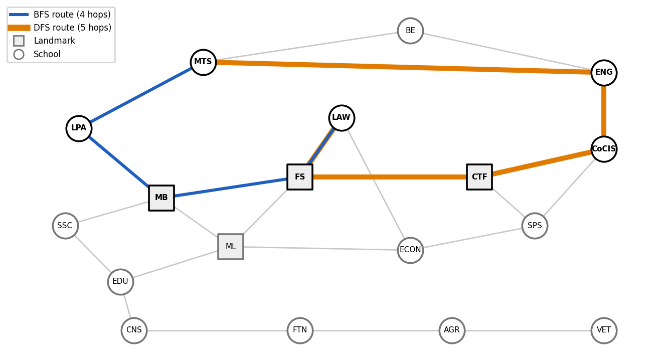
DFS stopped at the longer route because at Freedom Square it takes the alphabetically first neighbour, Central Teaching Facility, ahead of Main Building, and commits to that branch (CTF → CoCIS → ENG → MTS). It stops as soon as the goal is removed and never compares this with the shorter route through Main Building and LPA. DFS follows neighbour order, not path length.

Nodes expanded: is DFS always cheaper?
No. DFS expanded fewer nodes on pairs 1, 3, 4, 6, 8, 9 and 10 (for example 3 against 8 on pair 9) but more on pairs 2 (16 against 2), 5 (14 against 10) and 7 (16 against 5). In pair 2, CoCIS and School of Engineering are adjacent, so BFS needs 2 expansions. DFS goes to CoCIS’s alphabetically first neighbour, CTF, and wanders through most of the graph before backtracking to Engineering. DFS’s cost depends on neighbour order while BFS’s depends on the depth of the goal.

Memory trade-off
BFS must keep every node of the current depth in the frontier, about b^d nodes for branching factor b and depth d. Here b reaches 4 (Main Building, Freedom Square and Main Library each have four neighbours; the average is 2.67), and with reached off each node can also step back to its parent, so the frontier multiplies quickly. DFS keeps only the current path plus the unexplored siblings, O(b·m). With reached on, both frontiers are bounded by the 18 states, and our measured peaks were small (for example 4 for BFS and 6 for DFS on VET to CoCIS), so this campus is too small to show the effect. The lecture says memory, not time, limits BFS because the running time also grows as b^d, but a slow run only takes longer, while a frontier that does not fit in memory makes the run fail outright.

Limitation of the equal-cost assumption
Hops treat a 20 m walk and a 600 m climb as the same, so the fewest-hops route can be the longest to walk. On pair 10 (LPA to CoCIS), BFS’s 3-hop route through MTS and ENG would lose to DFS’s 4-hop route through MB, FS and CTF if the legs through MTS and ENG were long; whether it does depends on real distances. With real distances on the edges I would use Uniform-Cost Search from the lecture’s best-first table (f(n) = g(n)). It removes the node with the lowest path cost and is optimal for non-negative step costs.

5. Reflection
I would replace the uniform edge cost with measured walking distances (and ideally slope), so that the route finder minimises real walking effort and not hop count. This one change also makes Uniform-Cost Search and A* applicable.

